MSBA 653

TruSource
Customer Analytics Case Competition 2026:
Prediction of Customer Churn

UNIVERSITY OF LOUISVILLE
COLLEGE OF BUSINESS

- Introduction
  - Business Problem
The value of any business comes from its ability to adequately and consistently meet needs of their customers. This is often reflected in customer satisfaction, retention and expansion. In this case, we are looking at company’s historical data to find trends in customer behavior that may result in them churning. This discovery will be used to create a model that will be able to predict customer churn based on customer characteristics, behavior, company offerings, etc.
TruSource’s longevity and profitability would be better assured using this model. We consider some potential steps that TruSource may have taken in pursuit of this goal as well as some of the more obvious answers that may jump out at us. However, we will do a deeper dive into the data to find areas and subgroups that may not be as obvious. This way, we not only reenforce what is already in place and works but maximize resource allocation for better efficiency and equitable attention to various customer bases and needs. This is the main objective of this analysis and report.
This analysis matters because:
- Keeping existing customers is cheaper than finding new ones.
- High churn hurts revenue stability.
- Reducing churn increases the customer lifetime value and long-term growth.
- Early detection allows targeted retention efforts.
- Data Preparation
  - Data Overview
This dataset is representative of 5,636 customers data across 36 different features that describe customer services, personal information, and billing history. These features fall into one of three feature types: Identifier, Categorical and Numeric features shown in the table below. The dataset is relatively clean structured data with no duplicated rows. The data quality is good with a few missing values within certain identified columns, and these is addressed in the data cleaning portion of this report. The target variable(left_flag) was also coded as “1” for Customers that left and “0” for customers that stayed since the original dataset had them as “yes” and “no” respectively.

  - Target Feature
Our target variable is left_flag variable which shows a clear imbalance between customers who stayed and those who left. This is expected as this is a profitable business. Out of the total population, 4,140 individuals did not churn while 1,496 did, meaning roughly 73% remained and 27% exited in the third fiscal quarter. This distribution indicates that churn is a minority outcome but still represents a meaningful portion of the customer base, making it an important target for modeling and retention strategies.

Table 1 : Target Variable Frequency Table
Response | Left_flag | Count | Proportion

Customer left | Yes |  | 1496 | 27%
Customer Stayed | No |  | 4140 | 73%

Data Cleaning

Handling Missing Values

      - Total billed with 8 (0.14%) missing values:
Total billed has 8 missing values which could be because the bill has not been calculated yet for the customer or has not been uploaded into the dataset. For further analysis, the avg total billed can be used to replace these values to maintain the integrity of the dataset. This provides an accurate financial picture while maintaining the integrity of the dataset
Internet tech with 1212 (21.5%) missing values:
Internet tech has 1212 missing values and this feature represents the speed of the customer connection depending on whether users are on DSL(Digital Subscriber Line 5 – 100 mbps), Cable (5 – 1000 mbps) or Fiber optic 100 – 5+ gbps). We can keep this missing as “Unknown” internet speed, which will help us compare DSL vs. Fiber against customers with no recorded technology. With this, we can understand whether customers with “Unknown” internet tech are less engaged and at a higher risk of churning.

Recent offer with 3106 (55.1%) missing values:
Recent offer has 3106 missing values which could be because an offer has not been sent out to these customers yet. This is also a categorical variable with just over 55% of total observations not accounted for. We will treat this missing as customers who did not receive an offer. This helps us evaluate whether not receiving an offer is a barrier that causes customers to churn. Not all customers have the same contract term, so they may receive different offers at different times, which explains the higher number of missing values.

    - Removing Unnecessary Columns
During our data cleaning we deleted some unnecessary column like acct_ref, and cust_ref which are Customer Identifiers and fiscal qtr because they are not predictor variables that have any effect on the response variable (left_flag). With those three removed, there are 33 features that were used in building the model.

- Feature engineering
  - Handling Missing Values
Early analysis showed that customers who did not receive a recent offer tended to leave the company more often, especially those on month-to-month contracts. In our initial review, we determined that the missing values in the data represented customers who did not receive any offers. To capture this information effectively, we will a new simple indicator variable called offer_received_flag. This new variable marks a customer with a 1 if they got an offer and a 0 if they did not. This straightforward transformation lets us directly compare how recent offers affect the choice to leave, which helps improve future marketing plans.
  - Grouping Add-On Services to Capture Customer Engagement
Customers often sign up for several extra services like security, backup, or device protection. Because these items were closely linked and confusing to study alone, we combined them into one simple variable called has_any_addon. If a customer has one or more of these extras, they get a 1; if they have none, they get a 0. This single number helps us see if investing in extra services makes a customer more likely to stay with the company.
  - Retaining Contract and Pricing Variables
Based on EDA findings, contract term and monthly fees were strong predictors of churn, particularly for month-to-month customers. These variables were retained in their original form but were later evaluated for interaction effects within tree-based models to preserve interpretability.

- Exploratory Data Analysis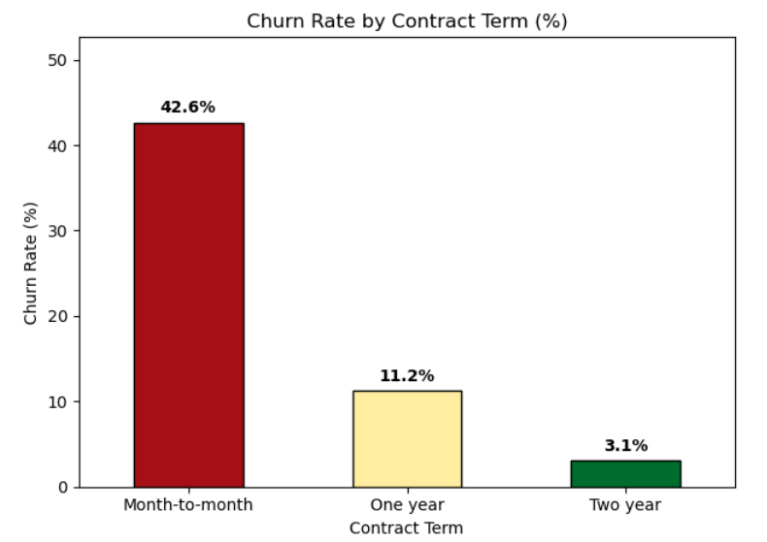
Fig 1: Churn Rate by Contract Term
This graph shows how churn changes by contract type. Customers on month-to-month contracts have the highest churn rate at about 42%, while those on one-year contracts churn around 11%, and two-year contracts have the lowest churn at about 3%. This analysis is important because it shows that longer contracts help keep customers longer. Month-to-month customers are more likely to leave and should be a key focus for retention efforts.
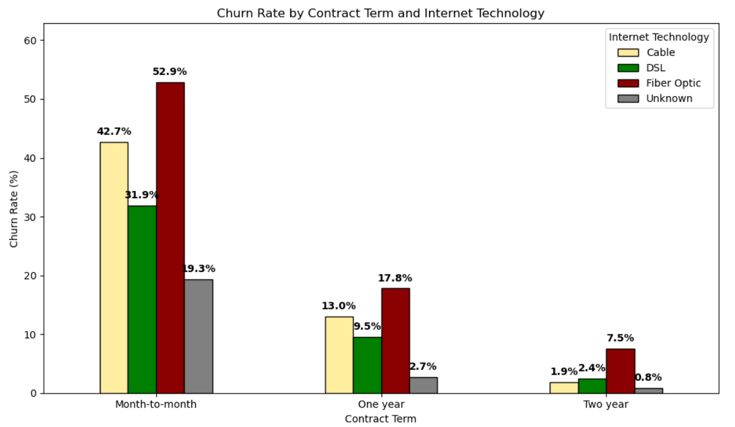 Fig 2: Churn Rate by Contract Term and Internet Technology
This graph breaks churn down further by both contract type and internet technology. For month-to-month customers, churn is highest among fiber optic users at about 53%, followed by cable users at around 43%, and DSL users at about 32%. Across all contract terms, fiber optic customers consistently show the highest churn rates, while churn decreases as contract length increases for every internet type. This analysis helps identify high-risk customer combinations, especially fiber optic users on month-to-month contracts.

  - Churn Rates for Month-to-Month Customers
Based on the earlier results, our team decided to focus mainly on month-to-month customers, since they show the highest churn rates. We further investigated how other predictive variables, such as monthly fees, payment methods, and recent offers, affect churn within this group. This deeper analysis helps identify specific factors that contribute to higher churn and supports more targeted retention strategies.
Table 2: Customer Engagement Features
Service Categories | Service Type | Churn Rate (%)
Add-Ons | Security | 29.8%
 | Protection | 43.1%
 | Backup | 38.1%
Streaming | Stream TV | 50.8%
 | Stream Movies | 50.1%
 | Stream Music | 50.3%
The table shows a clear difference in customer loyalty: the Security add-on contribute the least to Customer churn at a rate of just under 30%. This suggests people highly value the security service. In contrast, streaming services like TV, movies, and music have the highest churn rates, all around 50%. Having these services does not seem to stop customers from leaving, possibly because those services are seen as less important or easy to find somewhere else. This could also be because of the specific offering such as the availability of a vide area of music, movies, and TV compared to other services out there. This is all speculative as we did not have necessary information to determine the cause, we did think it was important to point out how these contribute to customer retention only half the time.
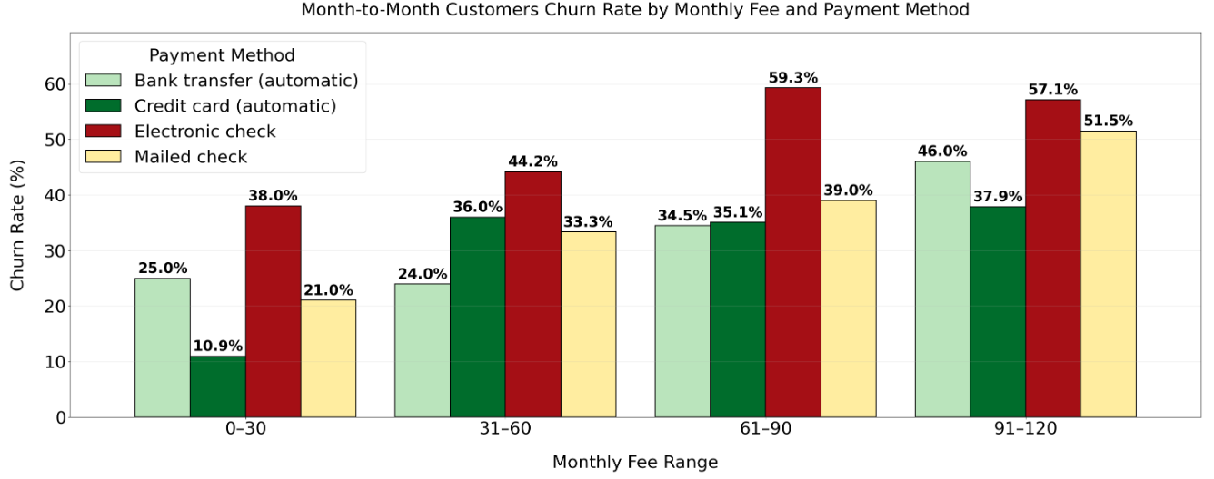
Fig 3: Month-to-Month Customers Churn by Monthly Fee and Payment Method
This graph looks at only month-to-month customers and shows how churn changes with monthly fees and payment methods. Churn generally increases as monthly fees rise, especially for customers using electronic check payments, where churn reaches close to 50% at higher fee ranges. This analysis helps us understand how pricing and payment methods influence cand which customers may need pricing incentives or alternative payment options.

Modeling

Modeling Approach
During the EDA, we observed that the relationship between the target variable and the feature variables were mostly non-linear in nature. Tree models capture this non-linear relationship best as opposed to linear regression. Not only do Tree models capture the relationships best, but they are also straight forward to explain and excellent across a classification problem like we have here. To identify the most effective approach for predicting customer churn, two binary classification models were evaluated using a consistent preprocessing pipeline and identical train-test splits. Model performance was compared using ROC-AUC.

Model Selection
We started by using a Random Forest model as our first choice. To measure its performance, we used the AUC metric as a baseline to compare with other models. Then, we continued with the XGBoost model to see if it could improve performance.
To test how well the model works on new customers, we split the data into 70% training and 30% testing. We shuffled the data before splitting to keep the balance between “Churn” and “Non-Churn” customers in both sets. The test_size = 0.3 gives a large enough sample to calculate reliable performance metrics, and we set random_state = 99 to make the results reproducible.
Table 3: Model selection for Customer Churn
Model | ROC-AUC Score (30% test set)

Random Forest  XGBoost | 0.891  0.894

Final Model
After evaluating both models, we selected XGBoost, a gradient boosting algorithm, as our final model. XGBoost builds multiple decision trees sequentially, where each new tree focuses on correcting errors made by the previous ones.
To ensure our model doesn’t overfit, we focused on balancing bias and variance. We achieved this by limiting the depth of our decision trees, using a smaller learning rate for gradual learning, and applying regularization to keep the model simpler. These approaches help balance the bias-variance tradeoff, preventing the model from learning noise and ensuring it captures meaningful patterns.

Hyperparameter Tuning
We performed a cross-validated grid search using Stratified 5-Fold Cross-Validation to maintain class balance in each fold within the training data only, ensuring that the test set remained a true holdout. This method allowed us to find the optimal combination of hyperparameters without overfitting.

Parameters Tuned Table
Parameters | Values Tested | Description
n_estimators | [400, 800] | Number of trees to build sequentially
max_depth | [4, 6, 8] | Maximum depth of each tree
learning_rate | [0.05, 0.1] | Controls how much the model learns at each step
subsample | [0.8, 1.0] | Fraction of data used for each tree
colsample_bytree | [0.8, 1.0] | Fraction of features used per tree
min_child_weight | [1, 3] | Minimum sum of instance weight needed in a child

Model Evaluation
The ROC-AUC was chosen as the primary evaluation metric due to its ability to measure classification accuracy. By analyzing the area under the curve, we can evaluate the model's performance across the full range of probability thresholds for both churn and non-churn classes.
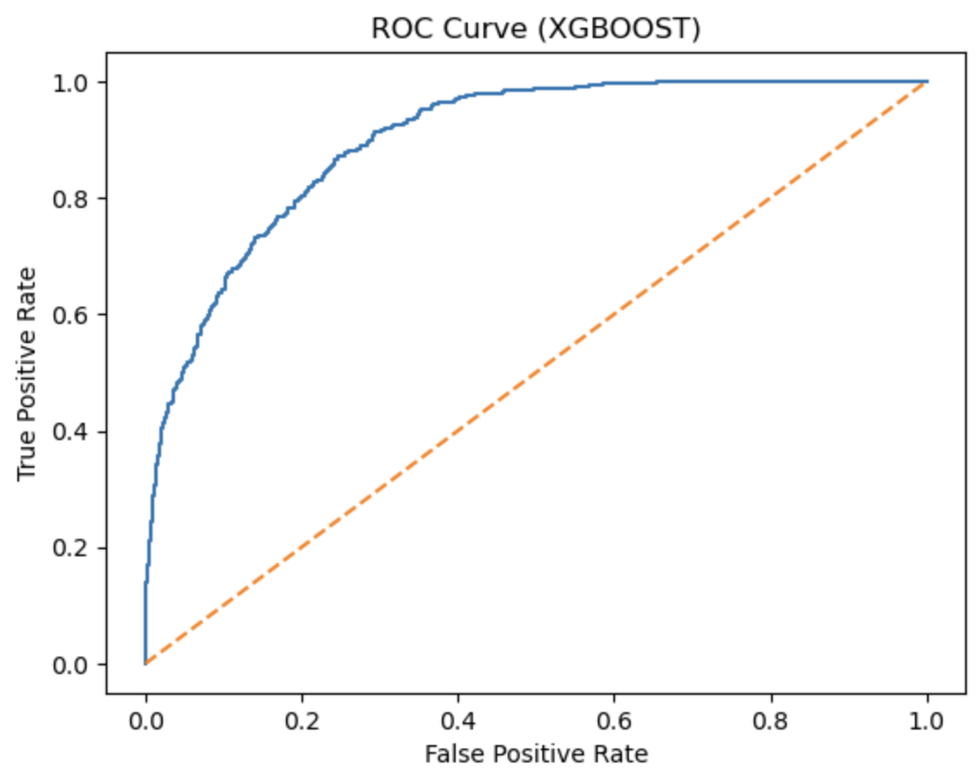
Key Performance Indicator Analysis

Feature Importance
To better understand the XGBoost model and identify the key drivers influencing predictions, we examined the top 10 features ranked by gain importance. Gain represents the improvement in model accuracy brought by each feature when it is used to split the data, making it one of the most widely used metrics for interpreting tree-based models.

Gain Importance
Using XGBoost’s built-in feature importance function, we extracted the features that contributed most to the model after tuning and training. The gain metric quantifies how much each feature improves the model’s decision trees, allowing us to identify the strongest predictors. The figure below highlights the top 10 features ranked by gain importance.
Overall, the model places the highest emphasis on contract term, internet plan type, and support/security add-ons, indicating that customer commitment level and service engagement are central to predicting outcomes. Features such as referral count, dependents, and payment method also appear among the top contributors, suggesting that demographic and behavioral attributes play a meaningful role in shaping customer behavior.

Fig 4: Feature Importance
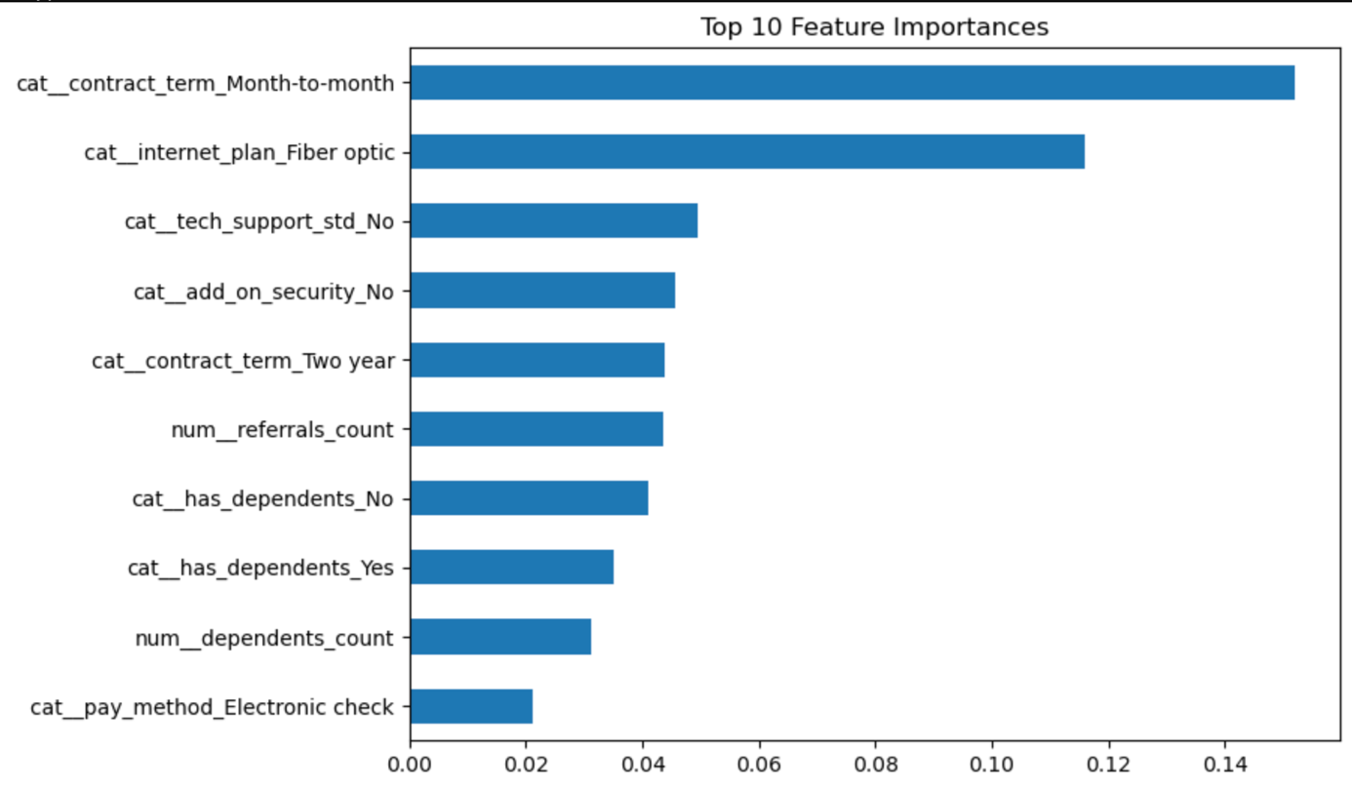

SHAP Value interpretation

In our feature importance analysis, SHAP is also a well-known method in post-model evaluation to compare and interpret the final features, since it generates numeric values that quantify each feature’s contribution to the model’s predictions. The top SHAP features from the model are shown in the figure. Below is a summary of the most influential features and how they relate to customer behavior in this mode.

Top SHAP Features (Interpretation of the Top 5)
- Referral Count (num__referrals_count)
This feature ranks highly in SHAP values, indicating that customers with more referrals significantly influence the model’s predictions. Higher referral counts tend to push predictions upward, suggesting that referral behavior is strongly associated with customer engagement patterns captured by the model.
- Contract Term: Month-to-Month (cat__contract_term_Month-to-month)
Month-to-month customers show a strong positive SHAP impact, meaning this group is more likely to drive higher predicted risk. This aligns with business intuition: customers without long-term commitments are more flexible and more likely to exhibit churn-like behavior.
- Dependents Count (num__dependents_count)
The number of dependents plays a meaningful role in shaping predictions. Higher dependent counts shift SHAP values, indicating that household size or family structure influences service needs and stability.
- Tenure in Months (num__tenure_mo)
Tenure is a stabilizing factor in the model. Higher tenure values generally reduce predicted risk, reflecting the loyalty and lower churn likelihood of long-standing customers.
- Monthly Fee (num__monthly_fee)
Monthly charges also show strong influence. Higher fees tend to increase SHAP values, suggesting that customers paying more may be more price-sensitive or more likely to reconsider their service.
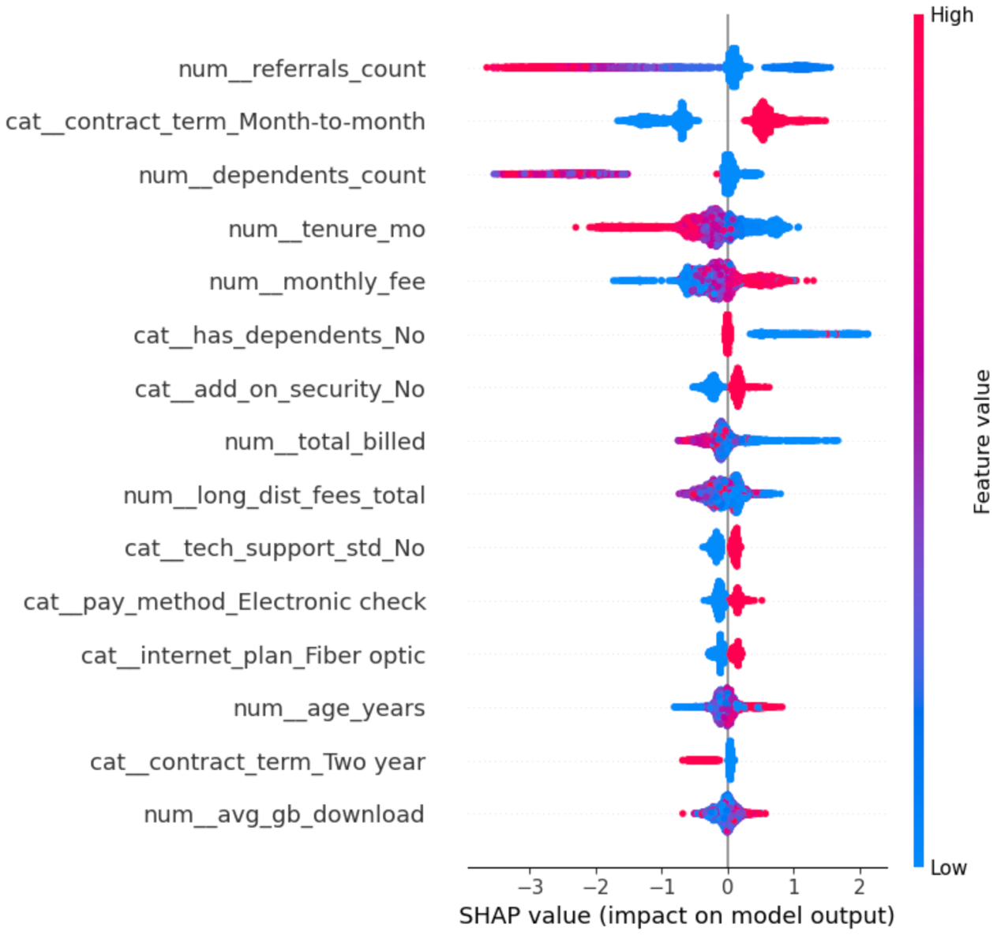

Comparison of Gain Importance and SHAP Value Features
To deepen our understanding of the model, we compared the top features identified by XGBoost Gain Importance with those highlighted by SHAP values. While Gain Importance measures how much each feature improves the model during tree construction, SHAP values quantify each feature’s contribution to individual predictions. Together, these methods provide a more complete view of which variables consistently influence the model and how they shape prediction outcomes.
Across both methods, several features emerge as consistently influential, indicating strong and stable predictive power. Below is a summary of the top SHAP features and how they align with the gain-based feature importance.

Comparison of Gain Importance and SHAP Value Features
When comparing the gain importance chart with the SHAP summary plot, several themes emerge:

Contract-Related Features Are Dominant in Both Methods
Features tied to contract term—especially Month-to-Month—rank among the top predictors in both gain and SHAP analyses. This confirms that commitment level is one of the strongest drivers of customer behavior in the model.

Service Engagement Features Appear in Both Rankings
Variables such as internet plan type, tech support, and add-on security show high gain importance and also appear prominently in the SHAP plot. These features reflect how deeply customers are engaged with the service ecosystem, which strongly influences predicted outcomes.

Demographic and Household Factors Matter Across Both Methods
Features related to dependents (both binary and numeric) appear in the top 10 gain importance list and also rank highly in SHAP values. This suggests that household structure plays a consistent role in shaping customer behavior.
Overall, both gain importance and SHAP values highlight a consistent set of influential features—particularly contract term, service engagement, and household characteristics. SHAP adds nuance by showing how these features push predictions up or down, while gain importance confirms their structural significance in the model. Together, these methods provide a robust understanding of the drivers behind the model’s predictions and help validate the reliability of the top features.

Segmentation

Based on the feature research and importance analysis generated from our predictive model, it has become clear that customer behavior is shaped by several distinct underlying factors. To better understand these behavioral patterns and design targeted strategies that reduce churn risk, we need to segment customers according to the most influential drivers identified in both the XGBoost gain importance and SHAP value analyses.
According to the importance rankings and directional SHAP effects, three categories of features consistently emerge as the strongest predictors of customer outcomes. These features represent different dimensions of customer commitment, engagement, and household structure. We selected the following three key binary features to define our segmentation framework:
- Contract Term: Month-to-Month
This feature captures the customer’s level of contractual commitment. Month-to-month customers show the highest SHAP impact and rank among the top gain-importance features, indicating that lack of contract commitment is one of the strongest predictors of customer instability and churn-like behavior.
- Tech Support Standard: Yes
This feature reflects the customer’s engagement with service add-ons. Customers who do not subscribe to technical support consistently appear as high-importance features in both gain and SHAP analyses. Low engagement with support services signals weaker attachment to the provider and lower switching barriers.
- Has Dependents: Yes
Household structure also plays a meaningful role. The presence or absence of dependents appears in both importance rankings, suggesting that family composition influences service needs, stability, and long-term retention patterns.
Using these three key features—each representing a different behavioral dimension—we applied the K-means clustering method to segment all customers in the dataset. After evaluating clustering performance and selecting a solution with relatively low inertia, we identified four distinct customer segments that reflect meaningful differences in commitment level, service engagement, and household characteristics.
These segments form the foundation for targeted retention strategies and allow us to tailor interventions to the specific drivers of churn within each group.

Cluster Variable | Segment 1 | Segment 2 | Segment 3 | Segment 4
contract Term(M2M) | 0.82 | 0.19 | 0.79 | 0.26
tech_support_std | 0.18 | 0.44 | 0.19 | 0.42
Has_dependents | 0.21 | 0.42 | 0.27 | 0.31
Group Size
Number | 1554 | 1347 | 1608 | 1127
Percentage | 27.6% | 23.9% | 28.5% | 20.0%
Other Factors
age_years | 61.3 | 33.4 | 32.8 | 62.0
tenure_mo | 14.1 | 56.6 | 12.1 | 57.9
Risk Indicator
Risk profile | High | Low | High | Low

Segment Analysis

Segment 1: Older Month-to-Month Customers With Low Engagement
This segment represents older customers who overwhelmingly remain on month-to-month contracts and show very low engagement with support services. They account for 27.6% of all customers. Their average tenure is only 14 months, and only 18% use tech support, indicating weak attachment to the service. Additionally, only 21% have dependents, suggesting fewer household-driven service needs.
This group is one of the highestrisk segments, as the combination of short tenure, low engagement, and lack of contract commitment makes them more likely to churn. Industry research consistently shows that customers without longterm contracts are significantly more likely to switch providers, especially when they have minimal service addons or support interactions. Low engagement reduces switching barriers, and older customers may also be more price sensitive or less inclined to explore additional services.-risk segments-term contracts are significantly more likely to switch providers, especially when they have minimal service add-ons or support interactions. Low engagement reduces switching barriers, and older customers may also be more price-sensitive or less inclined to explore additional services.
Therefore, the main pain point for this segment is the lack of perceived value, which leads to low engagement and high churn vulnerability. Strengthening early-life onboarding and offering contract incentives would be essential strategies for stabilizing this group.

Segment 2: Younger, Long-Tenure, Highly Engaged Customers
This segment represents younger customers who have been with the company for a long time and show strong engagement with support services. They make up 23.9% of all customers. Their average tenure is 56.6 months, and 43.5% use tech support — the highest among all segments. Additionally, 42% have dependents, indicating that household needs may drive service usage.
This segment has a low churn risk, as long tenure and high engagement are two of the strongest predictors of customer loyalty. Research in telecommunications and subscription services consistently shows that customers who actively use support services and have multiple household members relying on the service are less likely to switch providers. Their low month-to-month rate (only 19%) further reinforces their stability.
For this segment, the key insight is that engagement and tenure create stickiness. Their main needs revolve around maintaining service quality and receiving loyalty based benefits. Protecting this group through rewards, priority support, and referral incentives would help convert them into longterm advocates.-based benefits. Protecting this group through rewards, priority support, and referral incentives would help convert them into long-term advocates.

Segment 3: Young, New, Month-to-Month Customers With Low Engagement
This segment represents young customers who are new to the service, have very short tenure, and are predominantly on month-to-month contracts. They account for 28.5% of all customers — the largest segment. Their average tenure is only 12 months, and tech support usage is low at 19%. Only 27% have dependents, suggesting fewer household-driven service needs.
This is another high-risk segment, driven primarily by early-life churn dynamics. Industry studies show that the first 90 days of a subscription are the most critical for retention, and customers who do not adopt support services or add-ons early are significantly more likely to leave. Month-to-month contracts further increase churn likelihood, as these customers face no switching barriers.
The main pain point for this group is the lack of early engagement. Without strong onboarding, they fail to build habits or perceive value in the service. Targeted onboarding, usage nudges, and introductory bundle offers are essential to reduce churn in this segment.

Segment 4: Older, Long-Tenure, High-Engagement Customers
This segment represents older customers with long tenure, high engagement, and relatively low reliance on month-to-month contracts. They account for 20.0% of all customers. Their average tenure is 57.9 months, and 42% use tech support. Dependents are present in 31% of households, indicating moderate family-driven service needs.
This is a low-risk, highly stable segment. Long tenure and high engagement are strong indicators of loyalty, and their contract structure (only 25% month-to-month) further reduces churn likelihood. Older customers with established service patterns tend to value reliability and consistency, making them less likely to switch providers unless service quality declines.
The main insight for this segment is that they are deeply embedded in the service ecosystem. Their pain points are minimal, but they may be sensitive to price increases or service disruptions. Maintaining service quality and offering loyalty rewards will help preserve this group.

Recommendations

Segment 1: Increasing Early Engagement for Older Month-to-Month Customers
As analyzed above, this segment is most likely to churn due to a combination of short tenure, low engagement, and a heavy reliance on month-to-month contracts. Research across subscription-based industries shows that customers who do not engage with support services early in their lifecycle are significantly more likely to leave, especially when they lack contractual commitment. For older customers, unfamiliarity with digital tools and limited awareness of available support can further reduce perceived value.
To address these challenges, our mission is to increase early engagement, which is one of the most cost-effective ways to reduce churn and strengthen customer satisfaction. By helping customers understand and use the services available to them, we can increase perceived value and reduce the likelihood of switching.
Recommendation: Launch a Personalized Onboarding & Engagement Program
This program focuses on building confidence, increasing service usage, and strengthening perceived value among older month-to-month customers.
Implementation:
- Welcome Call Program: Provide a personalized welcome call within the first 30 days to help customers set up their services, understand key features, and learn how to access support.
- Guided Support Tutorials: Offer simple, step-by-step tutorials (phone or email) that introduce tech support benefits and demonstrate how to resolve common issues.
- Engagement Incentive: Provide a small bill credit or reward for completing onboarding steps, such as activating support features or attending a setup session.

Segment 2: Strengthening Loyalty for Younger, Long-Tenure, Highly Engaged Customers
This segment represents younger customers who have been with the company for a long time and show strong engagement with support services. Their low month-to-month rate and high dependents count indicate that they rely on the service for household needs and are deeply embedded in the ecosystem. As a result, they are one of the most stable and loyal segments.
To maintain their loyalty and encourage advocacy, we aim to reinforce long-term value and recognize their commitment. Loyalty reinforcement is a proven strategy for reducing churn and increasing customer lifetime value.
Recommendation: Introduce a Loyalty Rewards Program
This program recognizes long-tenured, highly engaged customers and encourages continued advocacy.
Implementation:
- Tiered Loyalty Benefits: Offer perks such as priority support, exclusive discounts, or early access to new features for customers who meet tenure and engagement thresholds.
- Referral Incentives: Provide rewards for referring new customers, leveraging this group’s high satisfaction and household influence.
- Annual Appreciation Credit: Offer a small yearly credit or bonus to reinforce long-term loyalty and signal appreciation.

Segment 3: Reducing Early-Life Churn for Young, New, Month-to-Month Customers
This segment is the most churn-prone due to extremely short tenure, low engagement, and high reliance on month-to-month contracts. Research shows that the first 60–90 days of a subscription are critical for retention, and customers who do not adopt support services early are significantly more likely to leave. Their youth and low household dependency suggest that they may be more price-sensitive and less committed.
To address these challenges, our mission is to reduce early-life churn by creating incentives for commitment and increasing early adoption of services.
Recommendation: Implement an Early-Life Contract Conversion Campaign
This campaign encourages new customers to transition from month-to-month to annual plans, increasing commitment and reducing churn.
Implementation:
- Introductory Contract Discounts: Offer a limited-time discount for switching to a 12-month plan within the first 60 days.
- Bundle Upgrade Offers: Provide discounted bundles that include tech support or security features to increase engagement and switching costs.
- Behavior-Triggered Outreach: Identify low-usage customers and send personalized nudges encouraging them to explore features or contact support.

Segment 4: Preserving Satisfaction for Older, Long-Tenure, High-Engagement Customers
This segment is highly stable, with long tenure, strong engagement, and low reliance on month-to-month contracts. Their loyalty is driven by reliability and consistent service quality. However, older long-tenure customers can be sensitive to price increases or service disruptions, which may erode trust if not managed carefully.
To maintain their satisfaction and prevent churn, we aim to preserve trust and service reliability, which are the core drivers of loyalty for this group.
Recommendation: Establish a Proactive Service Assurance Program
This program focuses on maintaining trust and stability for older, long-tenure customers.
Implementation:
- Advance Communication: Notify customers early about any service changes, maintenance windows, or potential disruptions.
- Priority Support Access: Provide a dedicated support line or faster response times for long-tenure customers.
- Stability Guarantee: Offer price-protection options or gradual increases to avoid sudden cost shocks.

